DSA Semester Project Report 2021

**Final Report**

INTERNET SERVICE PROVIDER

MANAGEMENT SYSTEM

AHMED MUJTABA 26617

M YOUSAF EJAZ 27014

A report submitted in part fulfilment of the course of

**Data Structure and Algorithms**

**Course Instructor: Mr.AHMAD ARSALAN**



Riphah School of Computing and Innovation (RSCI)

Riphah International University, Lahore Campus

November 20, 2022

**Declaration**

This report has been prepared on the basis of my own work. Where other published and unpublished source materials have been used, these have been acknowledged.

Word Count: 1279

1st Student Name: **Ahmed Mujtaba**

1st Student SAP ID: **26617**

2nd Student Name: **M Yousaf Ejaz**

2nd Student SAP ID:  **27014**

Date of Submission: 22-feb-2022

1st Student Signature:

2nd Student Signature:

Table of Contents

Abstract 3

Introduction 4

Project Specification 5

Project Screenshots 6

Conclusion 7

Abstract  **This is the management system of internet service provider company. This management system has two sides one side is employees side and other one is customers side. In our system user can perform the many functions like inserting details of the employee or customer as well as deleting, updating andsearching. Let talk about the important features of this project in the company can recording the details of employees as well as customer. In employee side the admin can record the personal details of all the employees like name, address, contact number , salary etc. Also admin can record the information to the customer like name, address, contact number and packages details etc.**

# Introduction

The ISP Management System is console-based project made using programming language like C++. It is great and efficient language for making such desktop System. With the advancement in technology, it is necessary for every company to also keep up with the advancing time and technology. So instead of doing everything hand written on registers there must be a computerized system that can help them to do their task more easily and efficiently without any problem and errors, as it is the case when every company tasks are done manually by human himself.

Let talk about the working of this management system, this management system has two linked list one is for employee side and other one is for customer side

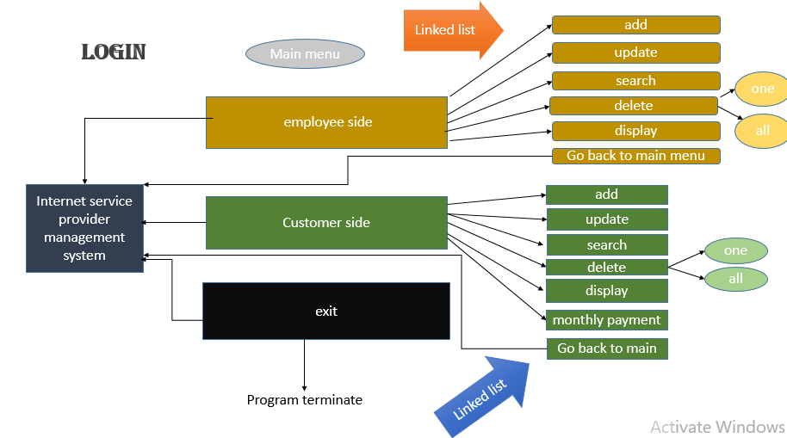

**Login:**

As this picture show first of all user have to login in the system . we save the default password for this purpose. The user name is based on company name suppose “msfiber” and the password is choice the company management let suppose “pak786786”. After login, a user have three option no 1 is for employee side, no 2 is for customer side and number no 3 is for exit button.

**Employee side:**

when the user press the 1 console open the employee menu. Employee menu have main 6 option insert the details of the employee in your company, update, search, delete, display and last but not the least go to the main menu. As you can see in delete option also have two option 1st to delete the details of only one employee and 2nd one is to delete the details of all employees.

**Customer side:**

When the user select no 2 option from the main menu the customer menu will open. This menu also has 7 option insert, update, search, delete, display, add monthly payment in customer payment and go to the main menu. As delete option also have two more option 1st to delete the record of a single customer and the 2nd to delete the record of all the customers.

**Exit :**

When the user press the 3 to exit the program the system will be terminated. It work like to logout from the system.

Project Specification

This software has used the concepts of Programming Fundamental (**PF**) like condition statements(if , if else) and loops (while loop, for loop) for reputing some tasks, goto statements, sleep function, getch() , system(“cls”), sytem(“pause”) the concepts of Object Oriented Programming (**OOP**) like inheritance, composition, association, polymorphism and access specifiers are used and data structures and algorithm (**DSA**) like linked list, searching (linear search) technique, sorting technique So we have try use all the concepts we studied so far and tried to implements these concepts into our project.

Our project have total 7 classes person, employee, enode, elist, customer, node and list

First one is **person class** (parent class) which have some common things of employee and customer so we make a parent class with the name of person. The common things are id, name, contact, address etc.

It has two child classes one is employee and second is customer. We use to singly linked list in our project first one is for employee side and second one is for customer side.

**employee class** has two data members post (designation) and salary of the employee and also have default constructor().

**enode class** has two data member one is the object of employee class which is the data of node and second is the next pointer which is the pointer in our node it point he next node.

**elist class** has two private member function head and tail of enode type. Also have default constructor that initialize head and tail are NULL. It contain the all the member function.

* void employeeMenu(); this function is the employee menu function the display the option for admin.
* void addEmployee(); this function is use to insert the employee details.
* void updateEmployee(); this function is use to update the employee details.
* void searchEmployee(); this function is use to search the employee details.
* void deleteEmployee(); this function is use to delete the data of a single employee.
* void deleteAllEmployee(); this function is use to delete the data of all the employees.
* void sort2(); this function is use to sort the display on console.
* void displayAllEmployee(); this function show the details of all employees on console.

**cutomter class**  has three data members date of join of customer, package, payment and have a constructor to initialize them to null.

**node class** has two data member one is the object of customer class which is the data of node and second is the next pointer which is the pointer in our node it point he next node.

**list class** has two private member function head and tail of node type. Also have default constructor that initialize head and tail are NULL. It contain the all the member function.

* void customerMenu(); this function is the customer menu function the display the option for admin.
* void addCustomer(); this function is use to insert the record of customer.
* void updateCustomer(); this function is used to update the previous record of the customer.
* void searchCustomer(); this function is used to search any thing from customer record.
* void deleteCustomer(); this function is used to delete the record of single customer.
* void deleteAllCustomer(); this function is used to delete the record of all the customer.
* void sort(); this function is use to sort the display.
* void displayAllCustomer(); this function is use to display the record of all the customer and also tells he total number of customer.
* void addMonthyPayment(); this function is use to add in monthly payment customer in subscribe package.

Last but not the least main menu function it has 3 option to admin as we discuss above.

We also add little bit file handling in main function just in login page

**class Diagram**

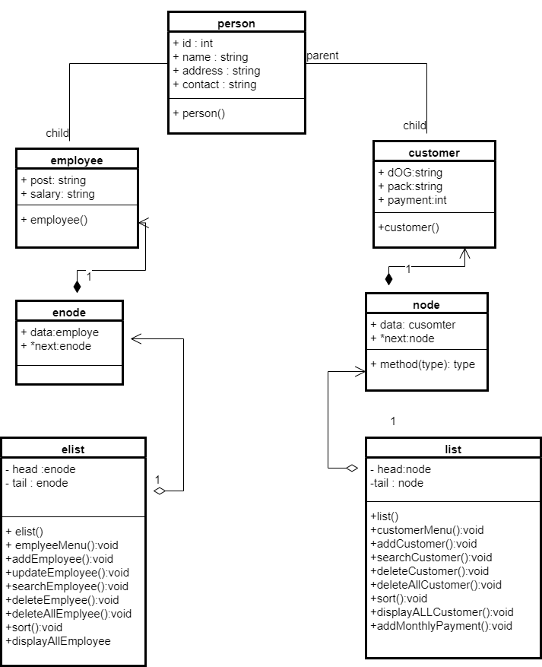

# Project Screenshots

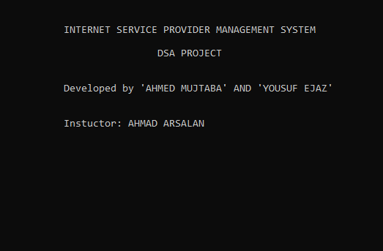

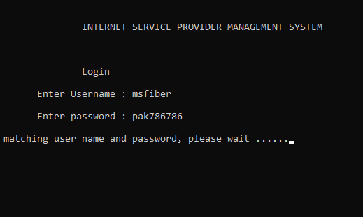

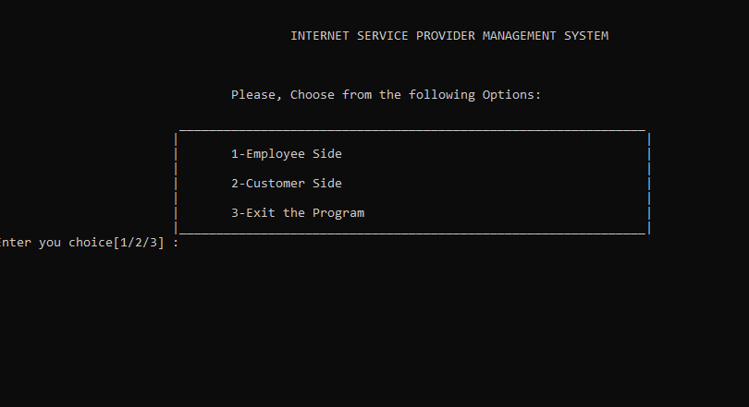

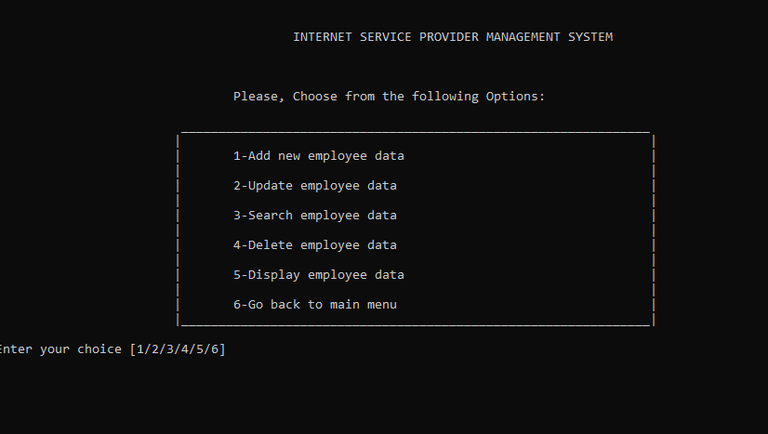

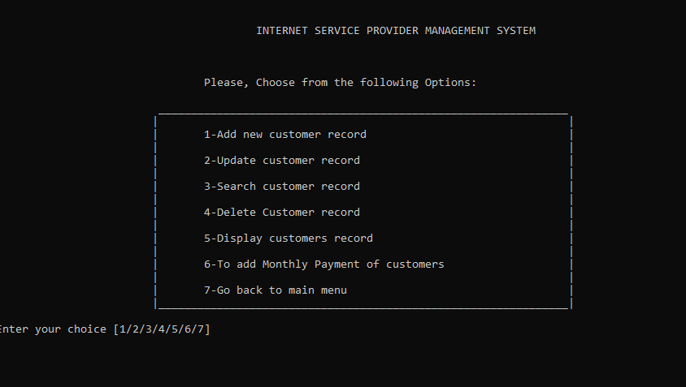

# Conclusion

This project provide a huge benefit to a company who can save the record of their employees as well as customers. This project is proved to a user friendly and efficient in achieving basic goals. The project is developed in such a way that a user with common knowledge can be easily use it. We try our best to make it realistic and secure.